MAMP 505: TBIs

1. TBIs - The Signature Injury of the Iraq/Afghanistan Conflicts

1.1 TBIs
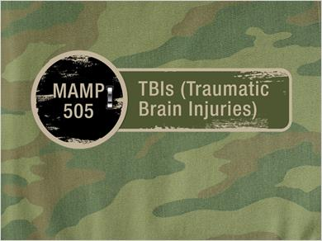
Notes:
MAMP 505: TBIs (Traumatic Brain Injuries)

1.2 Signature Injury
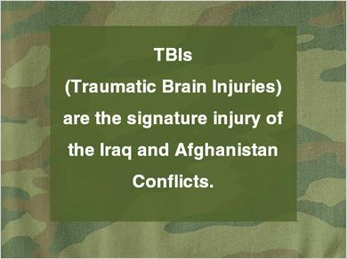
Notes:
TBIs (Traumatic Brain Injuries) are the signature injury of the Iraq and Afghanistan Conflicts.

1.3 Creation of the Term
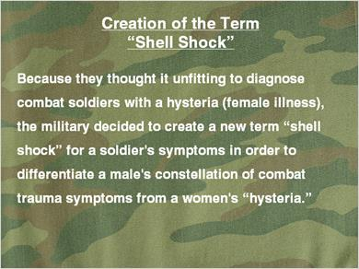
Notes:
Creation of the Term “Shell Shock”

Because they thought it unfitting to diagnose combat soldiers with a hysteria (female illness), the military decided to create a new term “shell shock” for a soldier's symptoms in order to differentiate a male's constellation of combat trauma symptoms from a women's “hysteria.”

1.4 Shell Shock…
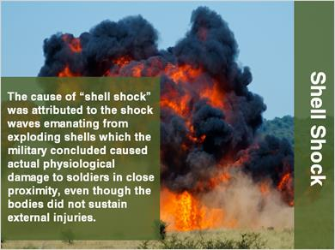
Notes:
Shell Shock

The cause of “shell shock” was attributed to the shock waves emanating from exploding shells which the military concluded caused actual physiological damage to soldiers in close proximity, even though the bodies did not sustain external injuries.

1.5 Shell Shock Victims…
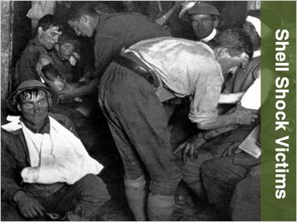
Notes:
Shell Shock Victims

1.6 Traumatic Brain Injury
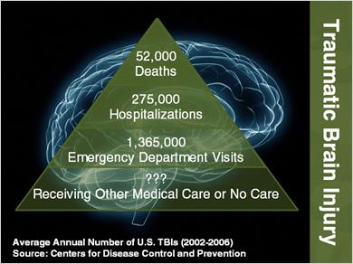
Notes:
Traumatic Brain Injury

52,000 Deaths
275,000 Hospitalizations
1,365,000 Emergency Department Visits
??? Receiving Other Medical Care or No Care
Average Annual Number of U.S. TBIs (2002-2006)
Source: Centers for Disease Control and Prevention

1.7 Cause of TBIs
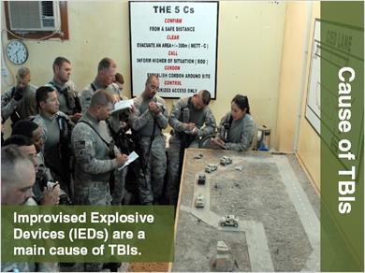
Notes:
Cause of TBIs

Improvised Explosive Devices (IEDs) are a main cause of TBIs.

1.8 Improvised Explosive Device (IED) Attacks
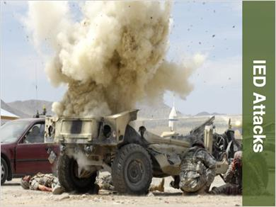
Notes:
IED Attacks

1.9 IED Attacks on the
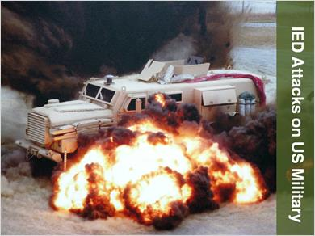
Notes:
IED Attacks on US Military

1.10 Aftermath of IED Attacks
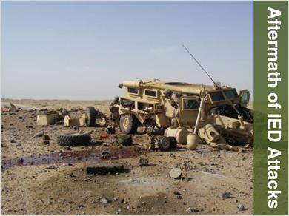
Notes:
Aftermath of IED Attacks

1.11 Threat of IEDs
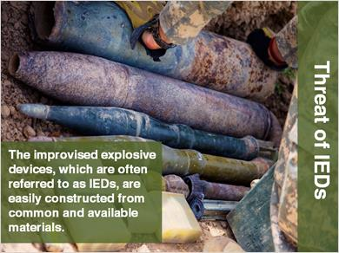
Notes:
Threat of IEDs

The improvised explosive devices, which are often referred to as IEDs, are easily constructed from common and available materials.

1.12 Threat of IEDs Continued
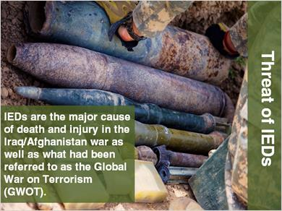
Notes:
Threat of IEDs

IEDs are the major cause of death and injury in the Iraq/Afghanistan war as well as what had been referred to as the Global War on Terrorism (GWOT).

1.13 Why Use IEDs
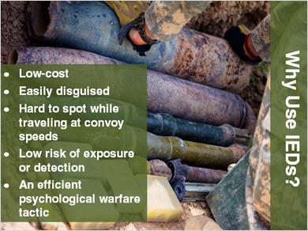
Notes:
Why Use IEDs?

- Low-cost
- Easily disguised
- Hard to spot while traveling at convoy speeds
- Low risk of exposure or detection
- An efficient psychological warfare tactic

1.14 IED Components
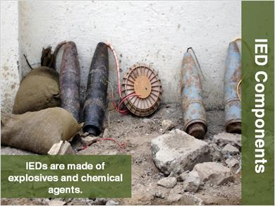
Notes:
IED Components

IEDs are made of explosives and chemical agents.

1.15 IED Design
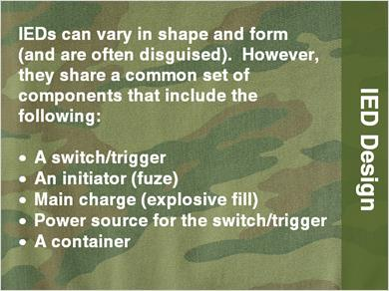
Notes:
IED Design

IEDs can vary in shape and form (and are often disguised). However, they share a common set of components that include the following:
- A switch/trigger
- An initiator (fuze)
- Main charge (explosive fill)
- Power source for the switch/trigger
- A container

1.16 VBIEDs
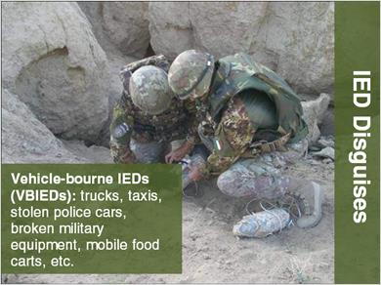
Notes:
IED Disguises

Vehicle-bourne IEDs (VBIEDs): trucks, taxis, stolen police cars, broken military equipment, mobile food carts, etc.

1.17 Canisters
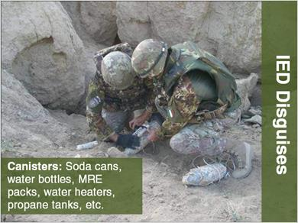
Notes:
IED Disguises

Canisters: Soda cans, water bottles, MRE packs, water heaters, propane tanks, etc.

1.18 Roadside Debris
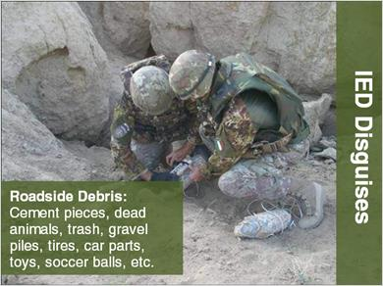
Notes:
IED Disguises

Roadside Debris: Cement pieces, dead animals, trash, gravel piles, tires, car parts, toys, soccer balls, etc.

1.19 Pipes
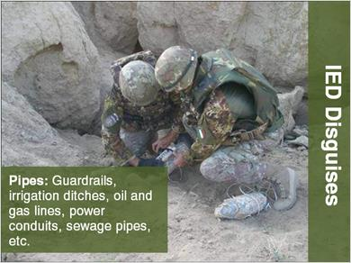
Notes:
IED Disguises

Pipes: Guardrails, irrigation ditches, oil and gas lines, power conduits, sewage pipes, etc.

1.20 Bags
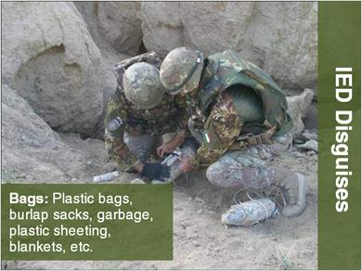
Notes:
IED Disguises

Bags: Plastic bags, burlap sacks, garbage, plastic sheeting, blankets, etc.

1.21 Packages
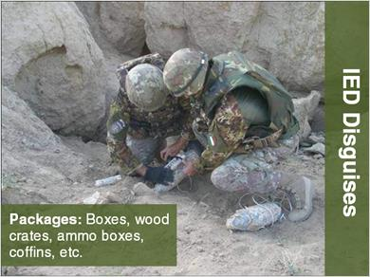
Notes:
IED Disguises

Packages: Boxes, wood crates, ammo boxes, coffins, etc.

1.22 Suicide Bombers
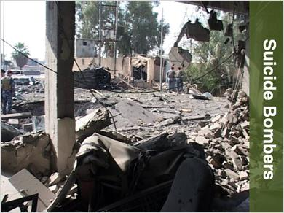
Notes:
Suicide Bombers

1.23 Four Types of Blast Effects…
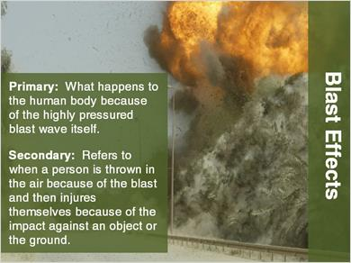
Notes:
Blast Effects

Primary: What happens to the human body because of the highly pressured blast wave itself.

Secondary: Refers to when a person is thrown in the air because of the blast and then injures themselves because of the impact against an object or the ground.

1.24 Blast Effects Continued
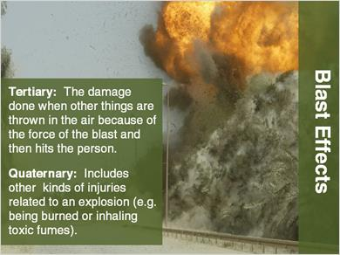
Notes:
Blast Effects

Tertiary: The damage done when other things are thrown in the air because of the force of the blast and then hits the person.
Quaternary: Includes other kinds of injuries related to an explosion (e.g. being burned or inhaling toxic fumes).

1.25 TBI Symptoms
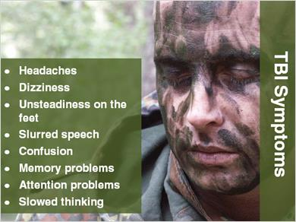
Notes:
TBI Symptoms

- Headaches
- Dizziness
- Unsteadiness on the feet
- Slurred speech
- Confusion
- Memory problems
- Attention problems
- Slowed thinking

1.26 TBI Symptoms Continued
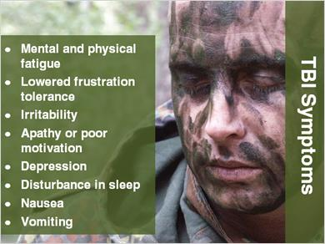
Notes:
TBI Symptoms

- Mental and physical fatigue
- Lowered frustration tolerance
- Irritability
- Apathy or poor motivation
- Depression
- Disturbance in sleep
- Nausea
- Vomiting

1.27 If We Don’t Ask…
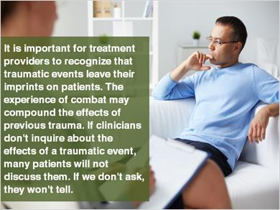
Notes:
It is important for treatment providers to recognize that traumatic events leave their imprints on patients. The experience of combat may compound the effects of previous trauma. If clinicians don't inquire about the effects of a traumatic event, many patients will not discuss them. If we don't ask, they won't tell.

1.28 Behavioral Health Treatment Programs and Trauma Issues
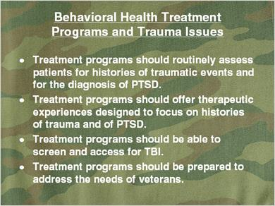
Notes:
Behavioral Health Treatment Programs and Trauma Issues
- Treatment programs should routinely assess patients for histories of traumatic events and for the diagnosis of PTSD.
- Treatment programs should offer therapeutic experiences designed to focus on histories of trauma and of PTSD.
- Treatment programs should be able to screen and access for TBI.
- Treatment programs should be prepared to address the needs of veterans.

1.29 Churchill Quote
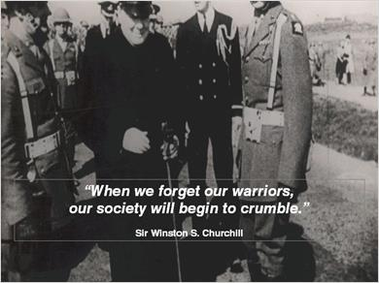
Notes:
“When we forget our warriors,
our society will begin to crumble.”
Sir Winston S. Churchill

1.30 Chapter 13 of Wheels Down
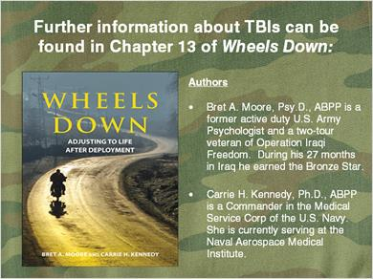
Notes:
Further information about TBIs can be found in Chapter 13 of Wheels Down:

Authors
Bret A. Moore, Psy.D., ABPP is a former active duty U.S. Army Psychologist and a two-tour veteran of Operation Iraqi Freedom. During his 27 months in Iraq he earned the Bronze Star.

Carrie H. Kennedy, Ph.D., ABPP is a Commander in the Medical Service Corp of the U.S. Navy. She is currently serving at the Naval Aerospace Medical Institute.

1.31 Presentation Author
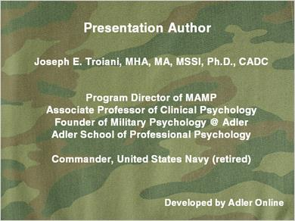
Notes:
Presentation Author

Joseph E. Troiani, MHA, MA, MSSI, Ph.D., CADC

Program Director of MAMP
Associate Professor of Clinical Psychology
Founder of Military Psychology @ Adler
Adler School of Professional Psychology

Commander, United States Navy (retired)

Developed by Adler Online

1.32 Editorial Photo Credits
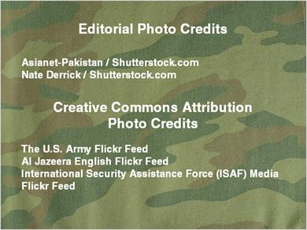
Notes:
Editorial Photo Credits

Northfoto / Shutterstock.com
Nate Derrick / Shutterstock.com

Creative Commons Attribution Photo Credits

The U.S. Army Flickr Feed
Al Jazeera English Flickr Feed
International Security Assistance Force (ISAF) Media Flickr Feed

