MAMP 505: Deployments

1.1 Deployments
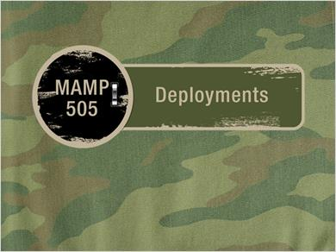

1.2 Impact of Multiple Deployments…
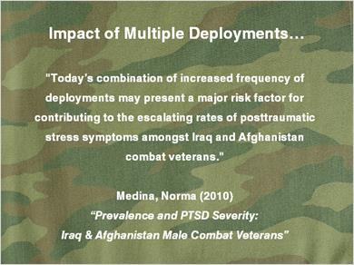
Notes:
Impact of Multiple Deployments…

"Today’s combination of increased frequency of deployments may present a major risk factor for contributing to the escalating rates of posttraumatic stress symptoms amongst Iraq and Afghanistan combat veterans."

Medina, Norma (2010)
“Prevalence and PTSD Severity:
Iraq & Afghanistan Male Combat Veterans”

1.3 Deployments Defined
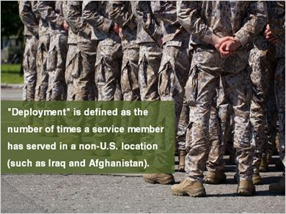
Notes:
"Deployment" is defined as the number of times a service member has served in a non-U.S. location (such as Iraq and Afghanistan).

1.4 Combat Deployments
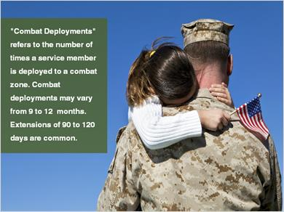
Notes:
"Combat Deployments" refers to the number of times a service member is deployed to a combat zone. Combat deployments may vary from 9 to 12 months. Extensions of 90 to 120 days are common.

1.5 Combat Environment
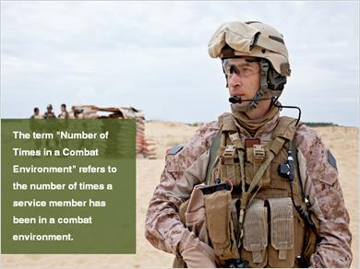
Notes:
The term "Number of Times in a Combat Environment" refers to the number of times a service member has been in a combat environment.

1.6 Number of Times in Combat
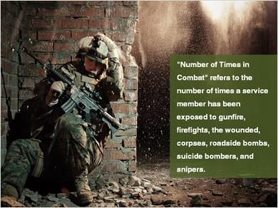
Notes:
"Number of Times in Combat" refers to the number of times a service member has been exposed to gunfire, firefights, the wounded, corpses, roadside bombs, suicide bombers, and snipers.

1.7 Troops who have served in Iraq and Afghanistan based on how often they have been deployed
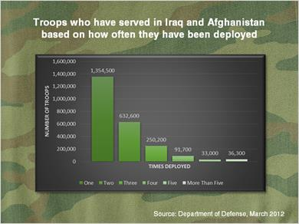
Notes:
Troops who have served in Iraq and Afghanistan based on how often they have been deployed

1.8 Review
(Drag and Drop, 10 points, unlimited attempts permitted)
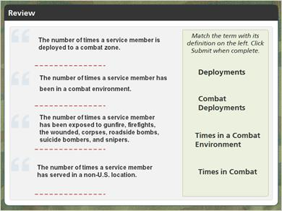
Drag Item | Drop Target
Times in Combat | The number of times a service member has been exposed to gunfire, firefights, the wounded, corpses, roadside bombs, suicide bombers, and snipers.
Times in a Combat  Environment | The number of times a service member has been in a combat environment.
Deployments | The number of times a service member has served in a non-U.S. location.
Combat  Deployments | The number of times a service member is deployed to a combat zone.

Drag and drop properties
Return item to start point if dropped outside the correct drop target
Snap dropped items to drop target (Snap to center)
Allow only one item in each drop target

Feedback when correct:
That's right! You selected the correct response.
Feedback when incorrect:
You did not select the correct response.

Notes:
The Drag and Drop Labels interaction features a text and label themed layout.

Use this text-based interaction for learners to correctly match terms with definitions, quotes by historical figures or products to features and benefits.

Deployments: The number of times a service member has served in a non-U.S. location.
Combat Deployments: The number of times a service member is deployed to a combat zone.
Times in a Combat Environment: The number of times a service member has been in a combat environment.
Times in Combat: The number of times a service member has been exposed to gunfire, firefights, the wounded, corpses, roadside bombs, suicide bombers, and snipers.

1.9 Presentation Author

Notes:
Presentation Author

Joseph E. Troiani, MHA, MA, MSSI, Ph.D., CADC

Program Director of MAMP
Associate Professor of Clinical Psychology
Founder of Military Psychology @ Adler
Adler School of Professional Psychology

Commander, United States Navy (retired)

Developed by Adler Online

