MAMP 505: The Experience of Combat

1.1 The Experience of Combat
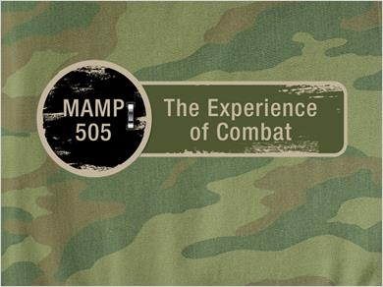
Notes:
MAMP 505: The Experience of Combat

1.2 Value of the Warrior
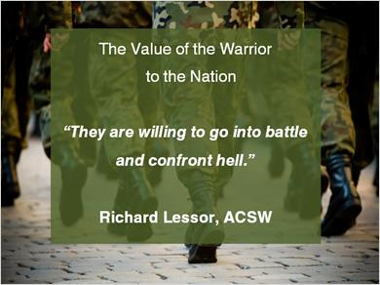
Notes:
The Value of the Warrior to the Nation
“They are willing to go into battle and confront hell.”
Richard Lessor, ACSW

1.3 Reality of Today's Conflicts

Notes:
Reality of Today's Conflicts

We will continue to be a nation at war.
A war that is in its Thirteen Year in 2014.
A war longer than any other conflict in American History.

1.4 Reality of Today's Conflicts Part 2
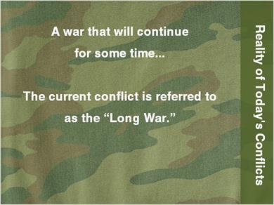
Notes:
A war that will continue for some time...
The current conflict is referred to as the “Long War.”

1.5 Horrific Experience of War
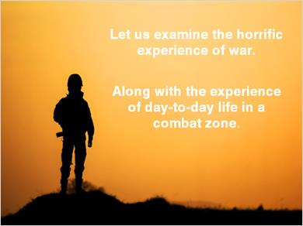
Notes:
Let us examine the horrific experience of war.
Along with the experience of day-to-day life in a combat zone.

1.6 Preparing for Combat…
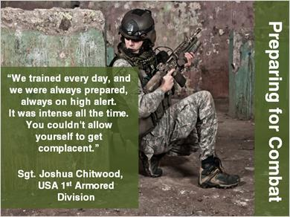
Notes:
Preparing for Combat
“We trained every day, and we were always prepared, always on high alert. It was intense all the time. You couldn't allow yourself to get complacent.”
Sgt. Joshua Chitwood, USA 1st Armored Division

1.7 Psychological Impact of Combat
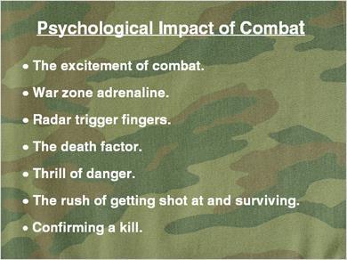
Notes:
Psychological Impact of Combat
- The excitement of combat.
- War zone adrenaline.
- Radar trigger fingers.
- The death factor.
- Thrill of danger.
- The rush of getting shot at and surviving.
- Confirming a kill.

1.8 Stress of Combat…
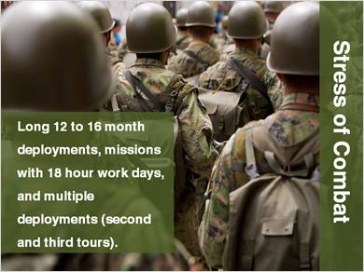
Notes:
Stress of Combat
Long 12 to 16 month deployments, missions with 18 hour work days, and multiple deployments (second and third tours).

1.9 Tension and Waiting
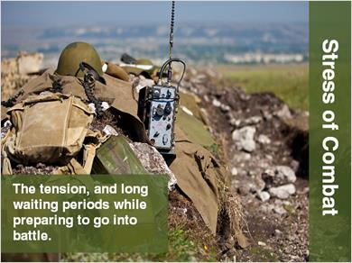
Notes:
Stress of Combat
The tension, and long waiting periods while preparing to go into battle.

1.10 Sleeping With Weapon
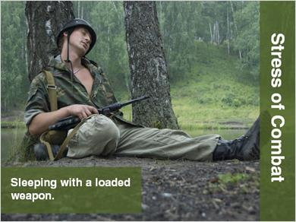
Notes:
Stress of Combat
Sleeping with a loaded weapon.

1.11 Living Under Field Conditions
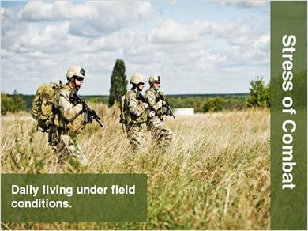
Notes:
Stress of Combat
Daily living under field conditions.

1.12 Harsh Environmental Conditions
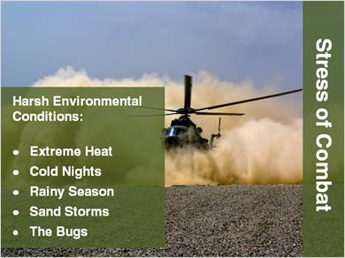
Notes:
Stress of Combat
Harsh Environmental Conditions:
- Extreme Heat
- Cold Nights
- Rainy Season
- Sand Storms
- The Bugs

1.13 Heightened Vigilance and Fear
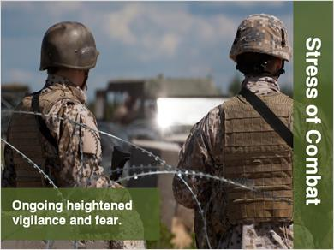
Notes:
Stress of Combat
Ongoing heightened vigilance and fear.

1.14 Terror of Combat
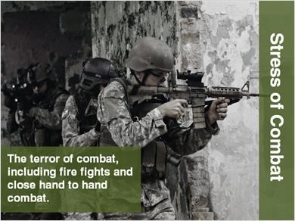
Notes:
Stress of Combat
The terror of combat, including fire fights and close hand to hand combat.

1.15 Sniper Attacks
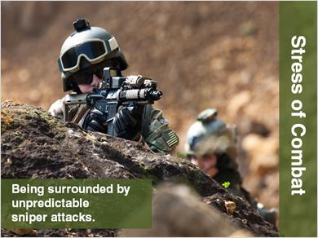
Notes:
Stress of Combat
Being surrounded by unpredictable sniper attacks.

1.16 Unknown Enemy
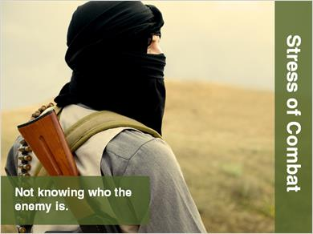
Notes:
Stress of Combat
Not knowing who the enemy is.

1.17 Face-to-Face With The Enemy
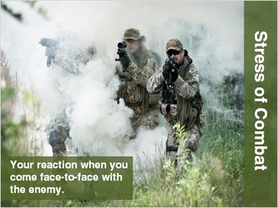
Notes:
Stress of Combat
Your reaction when you come face-to-face with the enemy.

1.18 Jihad
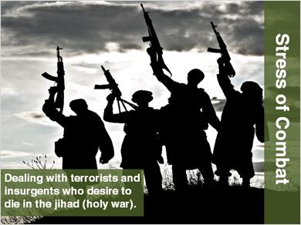
Notes:
Stress of Combat
Dealing with terrorists and insurgents who desire to die in the jihad (holy war).

1.19 IED Attacks
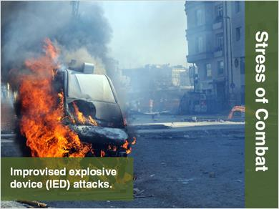
Notes:
Stress of Combat
Improvised explosive device (IED) attacks.

1.20 Rocket and Mortar Attacks
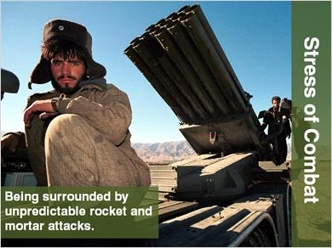
Notes:
Stress of Combat
Being surrounded by unpredictable rocket and mortar attacks.

1.21 Civilian Attacks
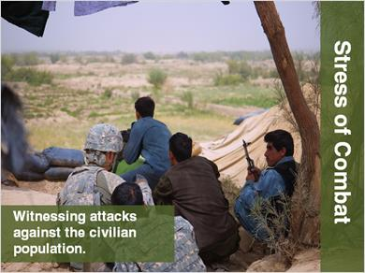
Notes:
Stress of Combat
Witnessing attacks against the civilian population.

1.22 Land Mines
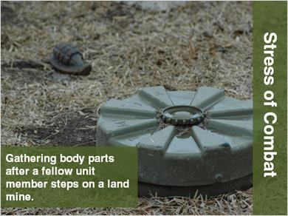
Notes:
Stress of Combat
Gathering body parts after a fellow unit member steps on a land mine.

1.23 Witnessing Death
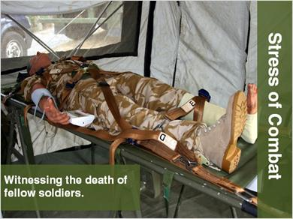
Notes:
Stress of Combat
Witnessing the death of fellow soldiers.

1.24 Grieving While In Combat
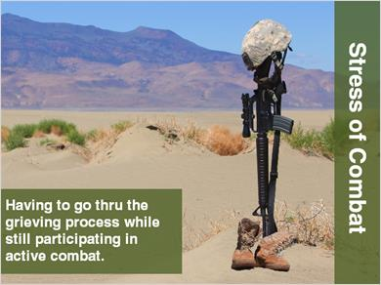
Notes:
Stress of Combat
Having to go thru the grieving process while still participating in active combat.

1.25 As Young As 18...
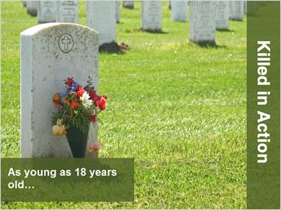
Notes:
Killed in Action
As young as 18 years old…

1.26 Youngest Soldier Killed
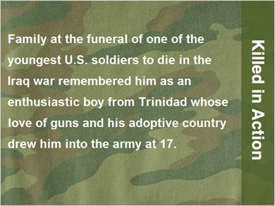
Notes:
Killed in Action
Family at the funeral of one of the youngest U.S. soldiers to die in the Iraq war remembered him as an enthusiastic boy from Trinidad whose love of guns and his adoptive country drew him into the army at 17.

1.27 Le Ron Wilson
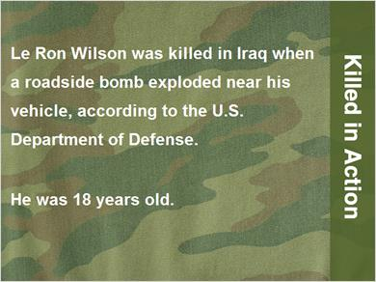
Notes:
Killed in Action
Le Ron Wilson was killed in Iraq when a roadside bomb exploded near his vehicle, according to the U.S. Department of Defense.
He was 18 years old.

1.28 As Old As 60...
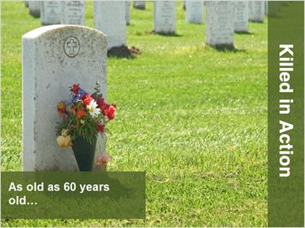
Notes:
Killed in Action
As old as 60 years old…

1.29 Oldest Soldier Killed
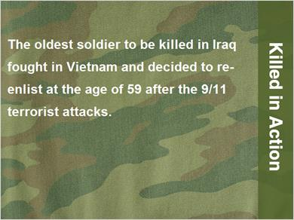
Notes:
Killed in Action
The oldest soldier to be killed in Iraq fought in Vietnam and decided to re-enlist at the age of 59 after the 9/11 terrorist attacks.

1.30 Steven Hutchison
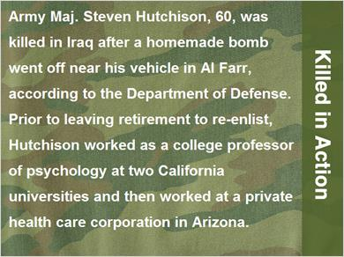
Notes:
Killed in Action
Army Maj. Steven Hutchison, 60, was killed in Iraq after a homemade bomb went off near his vehicle in Al Farr, according to the Department of Defense. Prior to leaving retirement to re-enlist, Hutchison worked as a college professor of psychology at two California universities and then worked at a private health care corporation in Arizona.

1.31 Trauma of Injury

Notes:
Trauma of Injury

1.32 Trauma of Disability
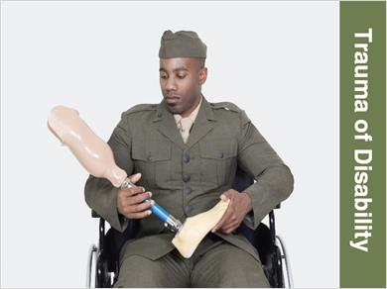
Notes:
Trauma of Disability

1.33 The Psychological Trauma - Thousand Yard Stare
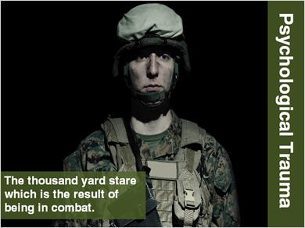
Notes:
Psychological Trauma
The thousand yard stare which is the result of being in combat.

1.34 Psychological Trauma - Shell Shock

Notes:
Psychological Trauma
Shell Shock...

1.35 Battle Fatigue…
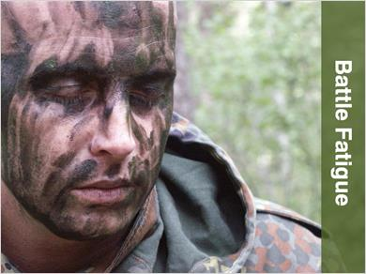
Notes:
Battle Fatigue

1.36 “Wheels Down: Adjusting to life after deployment” Quote
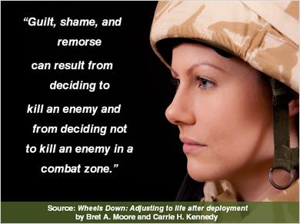
Notes:
“Guilt, shame, and remorse can result from deciding to kill an enemy and from deciding not to kill an enemy in a combat zone.”
Source: Wheels Down: Adjusting to life after deployment by Bret A. Moore and Carrie H. Kennedy

1.37 Additional “Wheels Down: Adjusting to life after deployment” Quotes
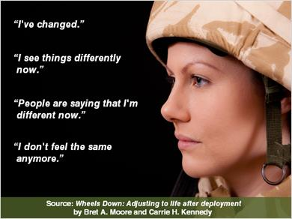
Notes:
“I've changed.”
“I see things differently now.”
“People are saying that I'm different now.”
“I don't feel the same anymore.”
Source: Wheels Down: Adjusting to life after deployment by Bret A. Moore and Carrie H. Kennedy

1.38 Deficiencies in the research literature…

Notes:
Deficiencies in the Research Literature
“Many gaps exist in the understanding of the full psychosocial effect of combat.”
New England Journal of Medicine

1.39 “Suicide in the Trenches”
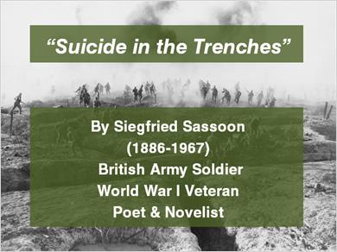
Notes:
“Suicide in the Trenches”
By Siegfried Sassoon
(1886-1967)
British Army Soldier
World War I Veteran
Poet & Novelist

1.40 Suicide in the Trenches Part 1
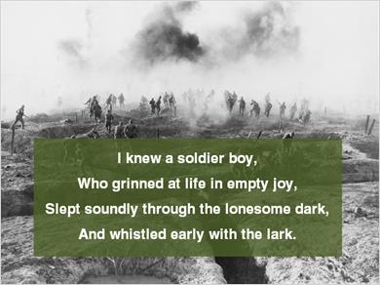
Notes:
I knew a soldier boy,
Who grinned at life in empty joy,
Slept soundly through the lonesome dark,
And whistled early with the lark.

1.41 Suicide in the Trenches Part 2
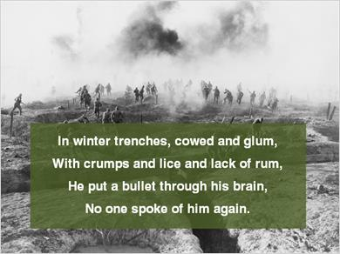
Notes:
In winter trenches, cowed and glum,
With crumps and lice and lack of rum,
He put a bullet through his brain,
No one spoke of him again.

1.42 Suicide in the Trenches Part 3
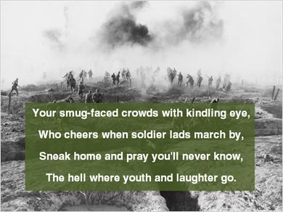
Notes:
Your smug-faced crowds with kindling eye,
Who cheers when soldier lads march by,
Sneak home and pray you'll never know,
The hell where youth and laughter go.

1.43 Presentation Author
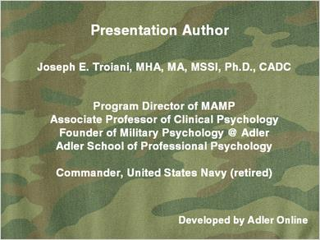
Notes:
Presentation Author

Joseph E. Troiani, MHA, MA, MSSI, Ph.D., CADC

Program Director of MAMP
Associate Professor of Clinical Psychology
Founder of Military Psychology @ Adler
Adler School of Professional Psychology

Commander, United States Navy (retired)

Developed by Adler Online

1.44 Editorial Photo Credits

Notes:
Editorial Photo Credits
Northfoto / Shutterstock.com
Nate Derrick / Shutterstock.com

