Dear Instructor,

As a new faculty member with Adler University’s Online Campus, you are asked to complete the Online Campus Online Faculty Orientation. This orientation will cover the basic information you need to navigate and teach within the Ember Learning Management System (LMS), along with other information you will need to be a successful adjunct faculty member at Adler University.

Orientation will run from START DATE to END DATE. It is imperative that you complete orientation by END DATE, or another faculty member may be invited to teach your course section.

Accessing Orientation
Orientation will be held in the Ember LMS, same as the course(s) you will be teaching. Once your Ember account is created and your Faculty Orientation is available, you will receive an email notification at your Adler email account inviting you to participate in the course. Please note that you will be unable to access Ember until you receive this email

To access Ember navigate to https://hotchalkember.com and log in using your university credentials (provided in a separate email from Adler University’s IT department). Please bookmark this page for future use.

Once you have logged in, use the “Courses” or “Courses & Groups” link at the top of your screen to access your Faculty Orientation and the course(s) you are assigned to teach. Courses and orientation is available starting two weeks before the start of a new session.
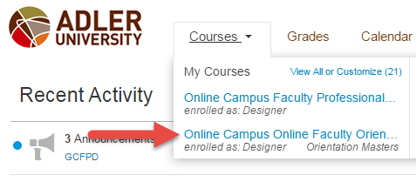

If you have any questions about orientation, please contact your Online Instructional Mentor Dr. Sherita Swinton-Fulton sherita.swinton-fulton@online.adler.edu

Sincerely,

Sheila A. Morales
Senior Coordinator, Academic Affairs
t: 408-834-7414| sheila.morales@online.adler.edu
17 N. Dearborn Street Chicago,IL 60602 Linkedin |Facebook

